**ASSIGNMENT 04**



**Name: ZOHAIB AHMER**

**Reg.no: FA20-BCS-038**

**Submitted to: DR kamran**

**Dated:11/6/2023**

**Subject:mad**

**COMSATS UNIVERSITY ISLAMABAD ATTOCK CAMPUS**

App.js:--

import { StyleSheet, View, Text, TextInput, Pressable, TouchableOpacity } from "react-native";

import { useState } from "react";

import { NavigationContainer } from '@react-navigation/native';

import { createStackNavigator } from '@react-navigation/stack';

import AsyncStorage from '@react-native-async-storage/async-storage';

const Stack = createStackNavigator();

export default function App() {

  return (

    <NavigationContainer>

      <Stack.Navigator

        screenOptions={{

          headerStyle:

            { backgroundColor: '#A0A0A0' },

          headerTintColor: 'black',

          headerTitleStyle: { fontSize: 25 }

        }}

        initialRouteName="SignUp">

        <Stack.Screen name="SignUp" component={SignUpScreen} />

        <Stack.Screen name="Login" component={LoginScreen} />

        <Stack.Screen name="Profile" component={ProfileScreen}

          options={({ navigation }) => ({

            headerRight: () => (

              <TouchableOpacity style={styles.btn} onPress={() => navigation.navigate('Login')}>

                <Text style={styles.textfont}>Logout</Text>

              </TouchableOpacity>

            ),

            headerLeft: null

          })}

        />

      </Stack.Navigator>

    </NavigationContainer>

  );

}

//SignUp Code

function SignUpScreen({ navigation }) {

  const [FirstName, setName] = useState('');

  const [LastName, setLstName] = useState('');

  const [Email, setEmail] = useState('');

  const [Pasword, setPass] = useState('');

  const [ConfirmPassword, setconfrmpass] = useState('');

  const [Gender, setGender] = useState('');

  const [Age, setAge] = useState('');

  const [Country, setconty] = useState('');

  const [city, setcity] = useState('');

  const [Street, setStreet] = useState('');

  const user = {

    FirstName,

    LastName,

    Email,

    Pasword,

    ConfirmPassword,

    Gender,

    Age,

    Country,

    city,

    Street

  };

  const clearInputs = () => {

    setName('');

    setLstName('');

    setEmail('');

    setPass('');

    setconfrmpass('');

    setGender('');

    setAge('');

    setconty('');

    setcity('');

    setStreet('');

  };

  const handleRegister = async () => {

    try {

      await AsyncStorage.setItem('user', JSON.stringify(user));

      clearInputs();

      console.log('User information stored successfully');

    } catch (error) {

      console.error('Error storing user information:', error);

    }

    navigation.navigate('Login')

  }

  return (

    <View style={styles.mainView}>

      <Text style={{ fontSize: 50, textAlign: 'center', color: '#fff' }}>Sign Up</Text>

      <TextInput style={styles.textBox} onChangeText={(text) => setName(text)} value={FirstName} placeholderTextColor={'#fff'} placeholder="First Name" />

      <TextInput style={styles.textBox} onChangeText={(text) => setLstName(text)} value={LastName} placeholderTextColor={'#fff'} placeholder="Last Name" />

      <TextInput style={styles.textBox} onChangeText={(text) => setEmail(text)} value={Email} placeholderTextColor={'#fff'} placeholder="Email" />

      <TextInput style={styles.textBox} onChangeText={(text) => setPass(text)} value={Pasword} placeholderTextColor={'#fff'} placeholder="Password" secureTextEntry={true} />

      <TextInput style={styles.textBox} onChangeText={(text) => setconfrmpass(text)} value={ConfirmPassword} placeholderTextColor={'#fff'} placeholder="Confirm Password" secureTextEntry={true} />

      <TextInput style={styles.textBox} onChangeText={(text) => setGender(text)} value={Gender} placeholderTextColor={'#fff'} placeholder="Gender" />

      <TextInput style={styles.textBox} onChangeText={(text) => setAge(text)} value={Age} placeholderTextColor={'#fff'} placeholder="Age" />

      <TextInput style={styles.textBox} onChangeText={(text) => setconty(text)} value={Country} placeholderTextColor={'#fff'} placeholder="Country" />

      <TextInput style={styles.textBox} onChangeText={(text) => setcity(text)} value={city} placeholderTextColor={'#fff'} placeholder="City" />

      <TextInput style={styles.textBox} onChangeText={(text) => setStreet(text)} value={Street} placeholderTextColor={'#fff'} placeholder="Street" />

      <TouchableOpacity style={styles.btn} onPress={handleRegister}>

        <Text style={styles.textfont}>Register</Text>

      </TouchableOpacity>

    </View>

  )

}

//Login  Code

function LoginScreen({ navigation }) {

  const [Email, setEmail] = useState('');

  const [Pasword, setPass] = useState('');

  const clearInputs = () => {

    setEmail('');

    setPass('');

  };

  const handleLogin = async () => {

    try {

      const storedUser = await AsyncStorage.getItem('user');

      if (storedUser) {

        const storedUserInfo = JSON.parse(storedUser);

        if (Email === storedUserInfo.Email && Pasword === storedUserInfo.Pasword) {

          clearInputs();

          console.log('Login successful');

          navigation.navigate('Profile', { user: storedUserInfo });

        } else {

          console.log('Invalid email or password');

        }

      } else {

        console.log('User information not found');

      }

    } catch (error) {

      console.error('Error retrieving user information:', error);

    }

  };

  return (

    <View style={styles.mainView}>

      <Text style={{ fontSize: 50, textAlign: 'center', color: '#fff', marginTop: 150 }}>Login</Text>

      <TextInput style={styles.textBox} onChangeText={(text) => setEmail(text)} value={Email} placeholderTextColor={'#fff'} placeholder="Email" />

      <TextInput style={styles.textBox} onChangeText={(text) => setPass(text)} value={Pasword} placeholderTextColor={'#fff'} placeholder="Password" secureTextEntry={true} />

      <Pressable style={styles.btn} onPress={handleLogin}>

        <Text style={styles.textfont}>Login</Text>

      </Pressable>

      <Pressable style={styles.btn}

        onPress={() => { navigation.navigate("SignUp") }}

      >

        <Text style={styles.textfont}>Create Account</Text>

      </Pressable>

    </View>

  )

}

//Profile  Code

function ProfileScreen({ route, navigation }) {

  const user = route.params?.user || {};

  const handleReset = async () => {

    try {

      await AsyncStorage.removeItem('user');

      console.log('Stored user data has been reset');

      navigation.navigate('Profile');

    } catch (error) {

      console.error('Error resetting stored user data:', error);

    }

  };

  return (

    <View style={styles.profileview}>

      <Text style={{ fontSize: 50, textAlign: 'center', color: '#fff' }}>Profile</Text>

      <Text style={styles.Profieltxt}>First Name: {user.FirstName}</Text>

      <Text style={styles.Profieltxt}>Last Name: {user.LastName}</Text>

      <Text style={styles.Profieltxt}>Email: {user.Email}</Text>

      <Text style={styles.Profieltxt}>Gender: {user.Gender}</Text>

      <Text style={styles.Profieltxt}>Age: {user.Age}</Text>

      <Text style={styles.Profieltxt}>Country: {user.Country}</Text>

      <Text style={styles.Profieltxt}>City: {user.city}</Text>

      <Text style={styles.Profieltxt}>Street: {user.Street}</Text>

      <TouchableOpacity style={styles.btn} onPress={handleReset}>

        <Text style={styles.textfont}>Reset</Text>

      </TouchableOpacity>

    </View>

  );

}

const styles = StyleSheet.create({

  textfont: {

    fontSize: 16,

    textAlign: 'center',

    justifyContent: 'center',

    color: '#fff'

  },

  Profieltxt: {

    marginTop: 20,

    fontSize: 24,

    textAlign: 'center',

    color: 'black',

    fontStyle: 'italic',

    fontWeight: 'bold',

    justifyContent: 'flex-start'

  },

  mainView: {

    flex: 1,

    marginTop: 0,

    backgroundColor: '#585A66',

    placeholder: {

      color: 'red',

    }

  },

  profileview: {

    flex: 1,

    marginTop: 0,

    backgroundColor: '#E8F0F8',

  placeholder: {

      color: 'blue',

    }

  },

  otextBox: {

    fontSize: 14,

    fontWeight: 'bold',

    borderWidth: 1,

    borderColor: '#fff',

    borderRadius: 20,

    paddingTop: 5,

    paddingBottom: 5,

    margin: 0,

    marginLeft: 60,

    marginRight: 60,

    marginTop: 7,

    textAlign: 'center',

    justifyContent: 'flex-start'

},

  btn: {

    alignItems: 'center',

    justifyContent: 'center',

    paddingVertical: 12,

    paddingHorizontal: 1,

    borderRadius: 20,

    elevation: 3,

    marginTop: 10,

    marginLeft: 60,

    marginRight: 60,

    backgroundColor: '#FF0000',

}

});

Output:-

Profile screen:-

-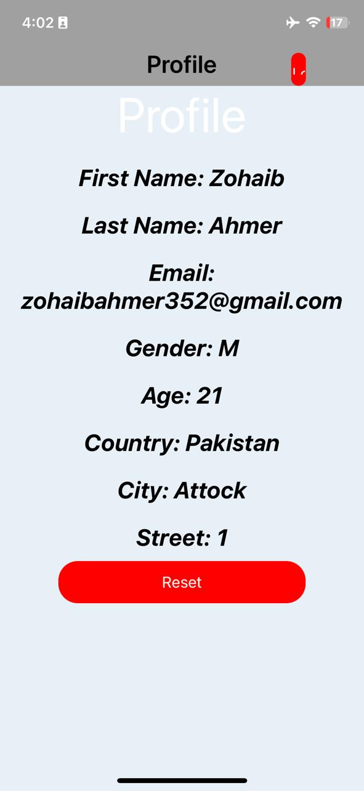

Login screen:-

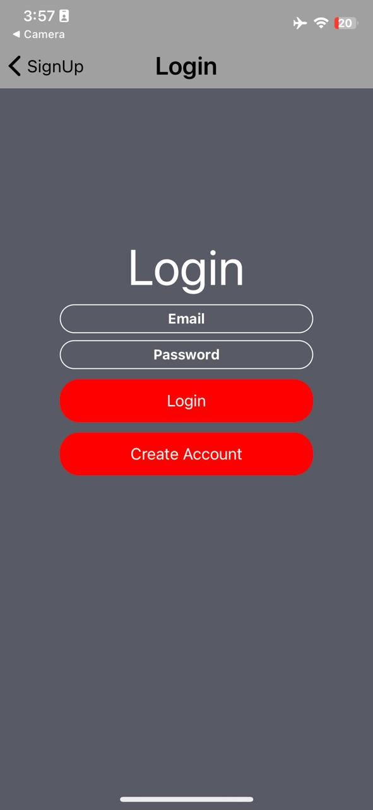

Signup screen:-

